AUGMENTED MATRIX METHOD TO SOLVE SYSTEM OF LINEAR EQUATIONS (Precalculus, Section 9.7)
For the following exercises, write the augmented matrix for the linear system.
- 8x − 37y = 8 2x +12y = 3
- 2x − 3y = −9 5x + 4y = 58
- 6x + 2y = −4 3x + 4y = −17
- 2x + 3y = 12 4x + y = 14
For the following exercises, solve the system by Gaussian elimination.
- $\left[ \left. \begin{matrix}1 & 0 \\ 0 & 0\end{matrix} \right| \begin{matrix}3 \\ 0\end{matrix} \right]$
- $\left[ \left. \begin{matrix}1 & 2 \\ 4 & 5\end{matrix} \right| \begin{matrix}3 \\ 6\end{matrix} \right]$
- $\left[ \left. \begin{matrix}-2 & 0 \\ 0 & 2\end{matrix} \right| \begin{matrix}1 \\ 1\end{matrix} \right]$
- $\left[ \left. \begin{matrix}6 & 2 \\ 3 & 4\end{matrix} \right| \begin{matrix}-4 \\ -17\end{matrix} \right]$
- $\left[ \left. \begin{matrix}-4 & -3 \\ 3 & -5\end{matrix} \right| \begin{matrix}-2 \\ -13\end{matrix} \right]$
- $\left[ \left. \begin{matrix} 3 & 4 \\ -6 & -8\end{matrix} \right| \begin{matrix} 12 \\ -24\end{matrix} \right]$
- $\left[ \left. \begin{matrix}11 & 10 \\ 15 & 20\end{matrix} \right| \begin{matrix}43 \\ 65\end{matrix} \right]$
For the following exercises, set up the augmented matrix that describes the situation, and solve for the desired solution.
- Every day, a cupcake store sells 5,000 cupcakes in chocolate and vanilla flavors. If the chocolate flavor is 3 times as popular as the vanilla flavor, how many of each cupcake sell per day?

- At a competing cupcake store, $4,520 worth of cupcakes are sold daily. The chocolate cupcakes cost $2.25 and the red velvet cupcakes cost $1.75. If the total number of cupcakes sold per day is 2,200, how many of each flavor are sold each day?

- You invested $10,000 into two accounts: one that has simple 3% interest, the other with 2.5% interest. If your total interest payment after one year was $283.50, how much was in each account after the year passed?

GRAPHING LINEAR INEQUALITIES IN TWO VARIABLES (Basic Mathematics Review, Section 7.8)

For the following exercises, graph the inequalities and show (shade in) the solution region.
- y ≤ x + 2
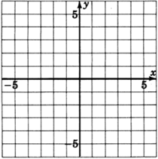

- y < −12x + 3

- 2x + 3y ≤ – 6

- 2x + 5y ≥ 20

- – 4x + 3y ≥ 12

- 3x > – 12

- 7y ≤ 21

- x + 4y > 4

GRAPHING SYSTEMS OF LINEAR INEQUALITIES IN TWO VARIABLES (UMUC Course Module 1, Topic II)
For the following exercises, graph the system of inequalities. Show (by shading in) the feasible region.
- y ≤ – x + 2 , y ≥ – 5x + 2

- 4x + y < 2 , y > – 2
- 3x + 2y ≥ 2 , x + 2y ≤ 2

- 4x + 3y > – 9 , 2x – 3y ≤ – 9
- 5x + 2y ≤ – 4 , x + 2y < 4
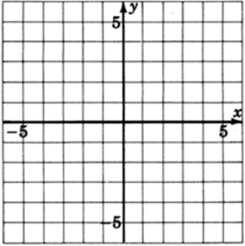
- x ≥ 0 , y ≥ 0

For the following exercises, graph the system of inequalities. Show (by shading in) the feasible region. Identify the ordered-pair “corner points” that define the feasible region.
- 3x + 2y ≥ 10 , 2x + 3y ≥ 10 , x ≥ 0 , y ≥ 0

- 4x + y ≤ 16 , x – 3y ≤ – 9 , x ≥ 0 , y ≥ 0
- 4x + y ≥ 8 , x + y ≤ 5 , x ≥ 0 , y ≥ 0

- y ≤ 5 , x – y ≤ 0 , x ≥ 0 , y ≥ 0
- 2x + 5y ≥ 20 , x ≤ 5 , y ≤ 5 , x ≥ 0 , y ≥ 0
- x + y ≥ 4 , x + 2y ≥ 5 , x ≥ 0 , y ≥ 0

